Embargoed until 12 September 2025, 10:30 a.m. CEST

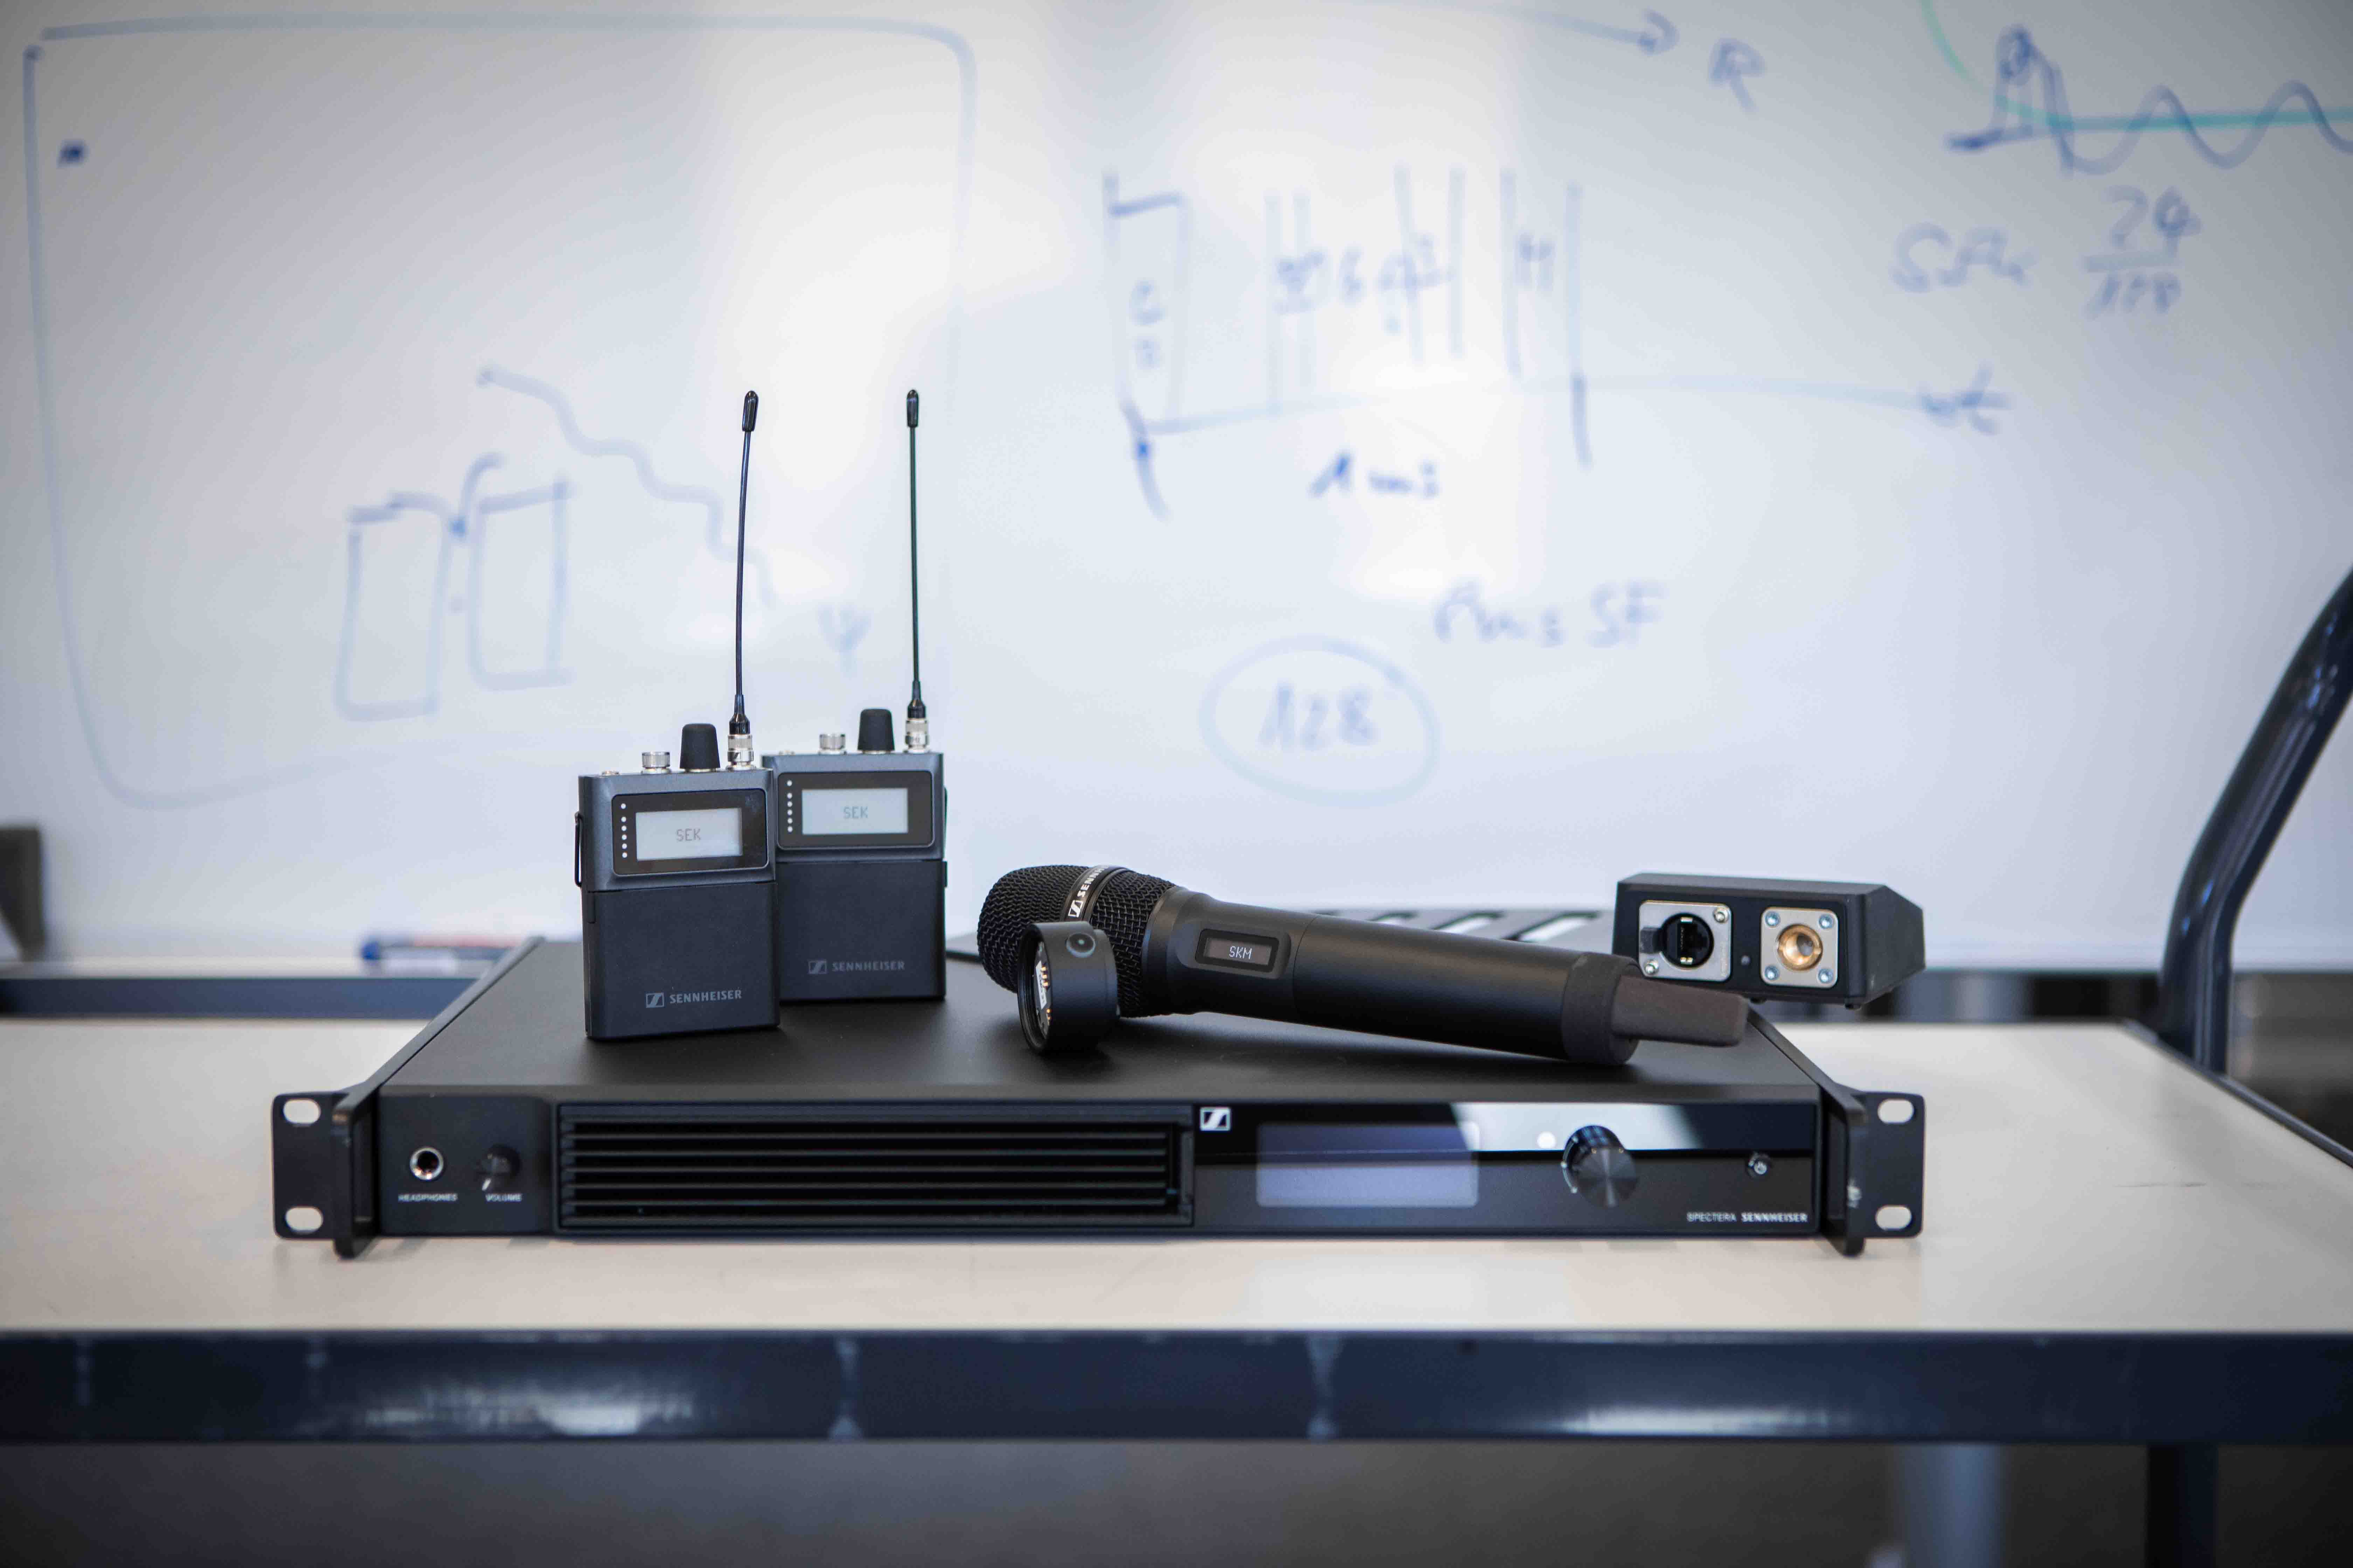Visit the Spectera Lab at IBC
Showcase reveals the most exciting Spectera additions in the pipeline

Wedemark/Amsterdam, 12 September 2025 – As an ecosystem, the bidirectional Spectera wideband wireless system will be continuously expanded with new software features, hardware devices and services going forward. Here’s a roundup of the sneak peeks available during IBC, an overview of the Spectera audio link modes plus links to a Spectera video series for those who want to explore the wideband wireless further.

Spectera SKM handheld and dedicated Command adapter
Sennheiser invites its IBC guests to be the first to try out prototypes of its Spectera SKM handheld microphone. Five working samples of the Spectera handheld for the UHF and the 1.4 GHz ranges will be available for demonstration at IBC.

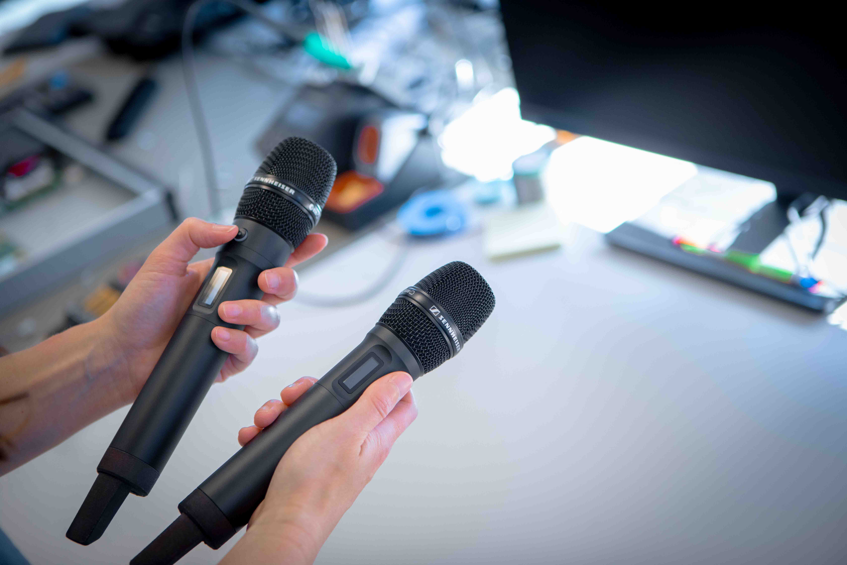 | Spectera SKM handheld prototypes will be shown at IBC; the transmitter on the left has been fitted with a Command adapter ring

The sleek, aluminium-anodised handheld with OLED display will have the Sennheiser standard capsule interface for both Sennheiser and Neumann microphone heads. The bidirectional data stream enabled by Sennheiser’s WMAS technology gives the operator full remote control of mic parameters such as low-cut, gain and more.

Command functionality will be added to the handheld via a Command adapter which screws in between the mic head and the microphone body. The programmable Command function, for example, adds a talkback channel to the microphone audio channel when an on-site reporter needs to exchange with the production team or production director on program content, such as potential next interview partners.

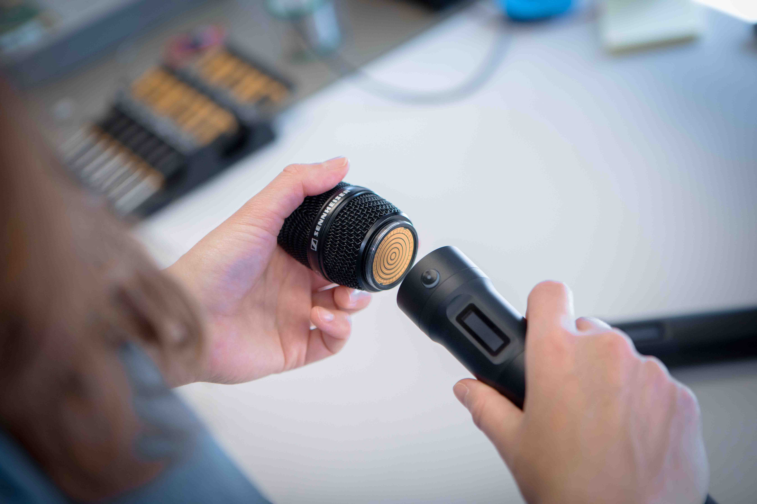 | The Command adapter for the Spectera SKM adds a talkback channel for the field reporter, for example

The Spectera handheld and the Command adapter are scheduled to start shipping in September 2026.

Command function for the SEK bodypack
The Command functionality and adapter for the Spectera bodypack will be made available from May 2026. Like the Command adapter for the handheld, it will allow the wearer to converse with the production crew.

SMPTE 2110 integration for broadcast production
IBC visitors will also be able to see a Spectera Base Station ZMAN prototype that carries a Merging ZMAN audio network module for AES 67 ecosystems. This module has the Base Station working according to the ST 2110-30 standard for audio transport, allowing for simple integration into high-quality broadcast production and distribution workflows.

SMPTE 2110 integration for Spectera is anticipated to be completed in August 2026.

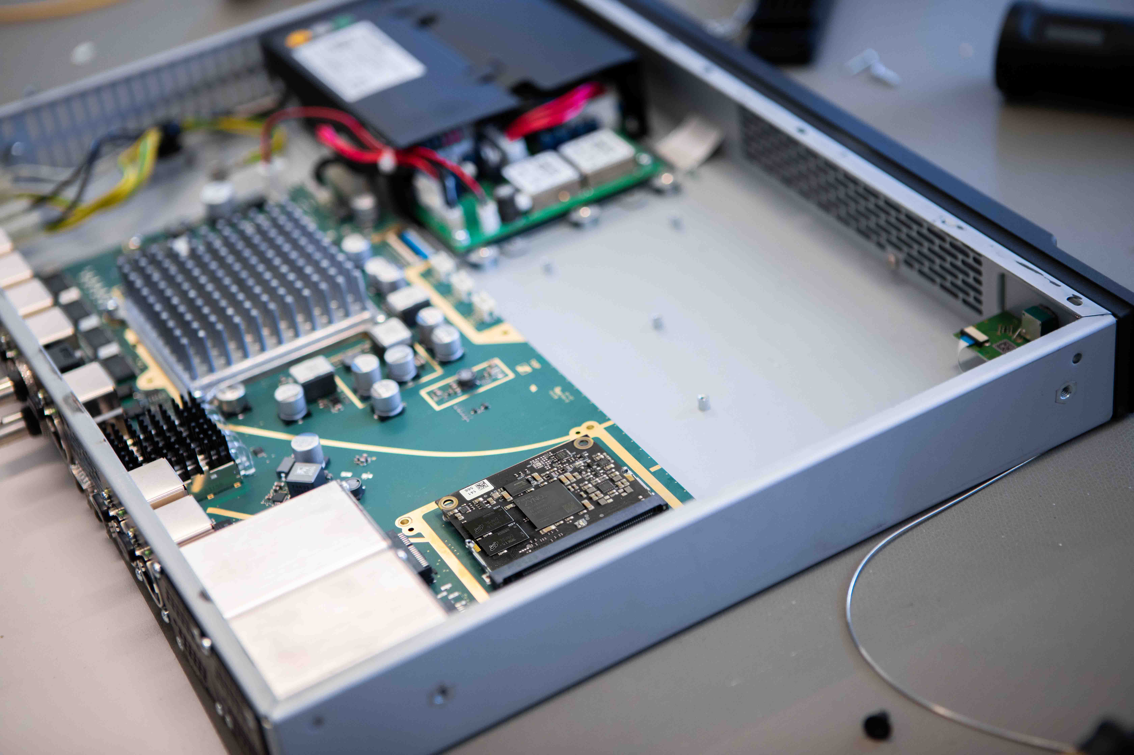 | Integration of Spectera into broadcast production workflows will be facilitated by a Merging ZMAN module (on the right-hand side of the larger PCB). It will make the Base Station work according to ST 2110-30

Engineer Mode
Also on show is the upcoming Engineer Mode for Spectera. This cue mode will provide engineers with the ability to listen in on up to 16 IEM mixes. The software update will be available from January 2026.

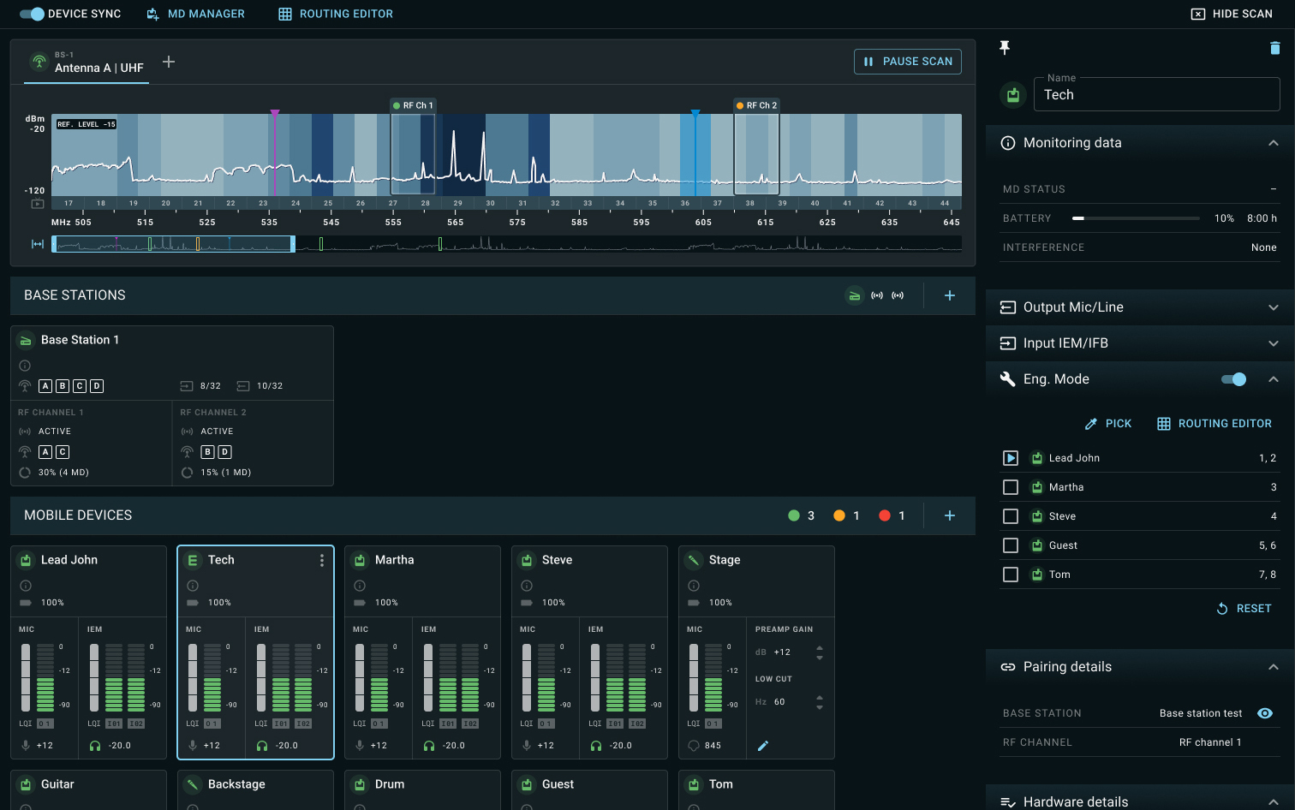 | Preview of the Spectera Engineer Mode on LinkDesk. This mode will become available in January 2026

Help shape Spectera!
Spectera is shaped by the industry’s feedback and ideas. Therefore, customers are asked to register their Spectera Base Station at my.sennheiser.com to receive software updates, release notes, and generally stay informed about latest developments. The portal features an idea space and open roadmap for Spectera, where customers can suggest, comment, and vote on new features.

Engineers are asked to join the Spectera Community on Discord to connect with fellow professionals and for a direct exchange with the Sennheiser team for quick support and sharing of ideas.

Please visit www.sennheiser.com/spectera-lab for more information.

Overview of Audio Link Modes
Spectera allows the operator to spread their resources as needed. The table below summarises the modes and their respective range, latency, battery runtime and channel use.

The Audio Link Modes at a glance

Informative video series
All components of the Spectera wideband wireless ecosystem are explained in a dedicated Spectera video series. The YouTube videos give valuable information on the Base Station, SEK bidirectional bodypacks, DAD antennas, Audio Link Modes and Spectera software tools. And for Spectera owners looking to set up their Base Station for the first time, this one-minute video gives instructions on how to proceed.

“Spectera has been designed to constantly evolve based on customer feedback,” says Theresa Vondran, Category Market Manager Pro Audio at Sennheiser. “We are very pleased to be able to share first functional prototypes with you at IBC, and give you a solid outlook on upcoming functionalities. At the same time, we’re excited to take your ideas for this ecosystem back home with us and thank you for joining this co-creation process.”

(Ends)

The high-resolution images accompanying this media release can be downloaded here.

About the Sennheiser Brand – 80 Years of Building the Future of Audio
We live and breathe audio. We are driven by the passion to create audio solutions that make a difference. This passion has taken us from the world’s greatest stages to the quietest listening rooms – and made Sennheiser the name behind audio that doesn’t just sound good: It feels true. In 2025, the Sennheiser brand celebrates its 80th anniversary. Since 1945, we have stood for building the future of audio and bringing remarkable sound experiences to our customers. While professional audio solutions such as microphones, meeting solutions, streaming technologies and monitoring systems are part of the business of Sennheiser electronic SE & Co. KG, the business with consumer devices such as headphones, soundbars and speech-enhanced hearables is operated by Sonova Holding AG under the license of Sennheiser.
www.sennheiser.com
www.sennheiser-hearing.com

Global Pro Audio Press Contact
Stephanie Schmidt
stephanie.schmidt@sennheiser.com
+49 (5130) 600 – 1275

